HOW TO PLAY THE SUPERHERO BOARDGAME:

AIM: Reach the finish line at the end of the boardgame.

Materials:
- Dice
- Boardgame
- 4 sets of question cards
- Counters
- Spare paper to draw diagram
To begin the game, each player rolls the dice and the person who has the highest total on the dice goes first.
Each player rolls the dice and moves their counter on the spaces like a traditional board game.
RULES:
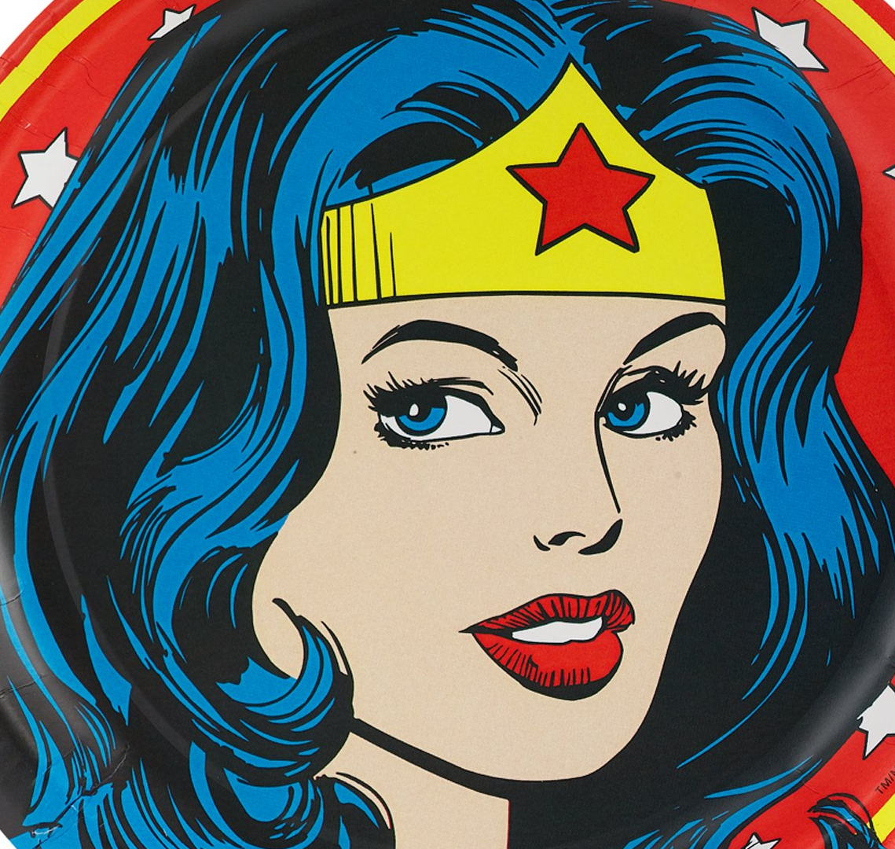
How to use the Superhero Cards:
Wonder Woman

When you land on the Wonder Woman square, ask the person on your right to pick up the Wonder Woman card and ask the question. If you get it right, you will follow the lassoo and move to the square that it is pointing. (Similar to the “snakes” in Snakes and Ladders.) If you answer incorrectly, you must move back 2 spaces.
These questions are based on general knowledge about fractions.

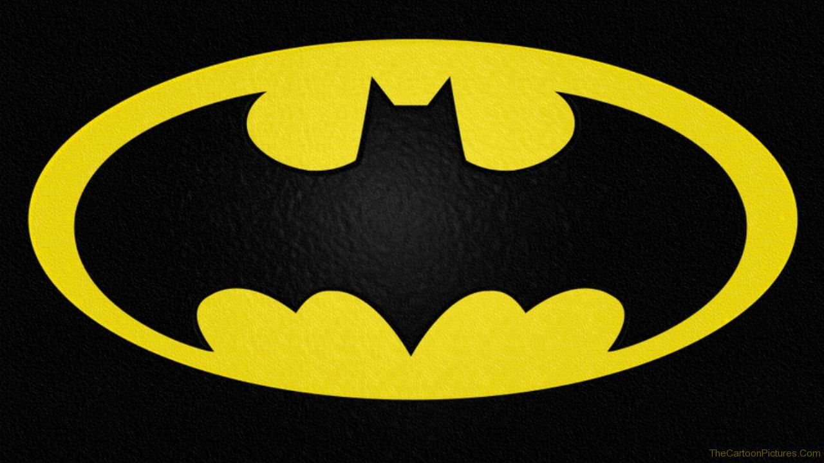
Batman

When you reach the Batman square, the person on your right will pick up the card and read out the question. If you answer correctly you can roll the die and have another turn. If you answer it wrong, you move your counter back 5 squares.

These cards ask fraction questions about quantities, collections, etc.

Flash

These cards require a partner. When you land on a Flash square, you and the partner on your right have to complete this challenge. The player who landed on the Flash square has 1 minute to draw a diagram showing the fraction. You might draw a pizza, shaded rectangles, apples, cakes, etc. Your partner has 1 minute to work out what fraction it is showing.
On the equivalent fraction cards you must tell your partner that you have drawn an equivalent fraction and they must guess what fraction is your card. For example if you card asks you to draw the equivalent of 1/2 and you draw a diagram showing 2/4, you partner has to work out what the equivalent of 2/4 is. Therefore the correct answer is 1/2.
If your partner guesses the correct answer you move both your counters to the next Flash check point. This may be different for each player if one is ahead of the other. If your partner guesses the wrong answer then both of you must move back to the last Flash checkpoint on the board.
If your on the first Flash checkpoint you remain where you are.


Supergirl

These cards give players a superpower to assist them during the game.
These cards include:
The Cloak of Invisibility
This card allows you to not participate in a challenge on the Wonder Woman and Batman cards. However you will lose you turn. To use this card you may draw this card after you have landed on a Superhero square.
Copy-Cat!
This card allows you to mimic the last superpower used in the game. Example if the Cloak of Invisibility was the last card used then you can lay this card and copy and use the cloak of invisibility.
Power of Negation
This card allows you to cancel another person’s superpower. Once a player ahs announced they are using a superpower,Once player they are using a superpower, simply lay your card out so everybody can see to cancel that person’s entire move.
Wonder Woman’s Lassoo
This card allows you to boost another player forward or backwards by 5 spaces. You lose a turn when you use this card. Simply lay the card out on your move and say which the players name and move their counter forwards or backwards.
Super X-ray Vision
This card allows you to request to see another person’s superhero card for one of yours.
Flash’s Run
This card allows you to double the amount of the dice.

Note For Teachers:

This game is a guide only
Please feel free to adapt the questions to suit your own classes’ needs and abilities. This is a start up only and so there only a limited number of questions.
This game is set up to be played by 4-6 players.
For a whole class play, the game needs to be printed multiple times so that they can be split into groups.
Alternatively the rules can be adapted for whole class play with a blown up game board and the class can be split into teams.
The game is based on fractions however this can also be adapted to suit any grade level or topic and content.

Thank you for using this resource!

Please feel free to leave a review on the TES Australia website


